Perioperative and Long-Term Risks in Obese Living Kidney Donors: A Systematic Review and Meta-Analysis

Asad Naveed, MBChB, MPH (1), Abdul Al Seraji, BS (2), Abdurrahmaan Mahmoud, BS (2), Hector R. Perez-Gilbe, MPH (3), Andrew Odegaard, MPH, PhD (4), Simeon Adeyemo, MS (2), Katafan Achkar, MD (5), Lama Abdelnour, MD (6), Abimereki D. Muzaale, MD MPH (7), Rebecca S. Ahdoot, MD (2), Antoney J. Ferrey, MD (2), Deborah B. Adey, MD (8), Krista L. Lentine, MD, PhD (9), Christina Papageorge, MD (10), Saad Shebrain, MD (10), Dorry L. Segev MD, PhD (12), Jayme E. Locke MD, MPH (12), Andrew D. Rule, MD (13), Fawaz Al Ammary, MD, PhD (2)

(1) Department of Surgery, Sault Area Hospital, Sault Ste Marie, ON, Canada
(2) Department of Medicine, University of California Irvine, Orange, CA, United States
(3) UCI Libraries, University of California Irvine, Irvine, CA, United States
(4) Department of Epidemiology & Biostatistics, University of California Irvine, Irvine, CA, United States
(5) Department of Medicine, Houston Methodist Hospital, Houston, TX, United States
(6) Department of Medicine, University of California Los Angeles, Los Angeles, CA, United States
(7) Department of Surgery, Johns Hopkins University, Baltimore, MD, United States
(8) Department of Medicine, University of California San Francisco, San Francisco, CA, United States
(9) Department of Internal Medicine, Saint Louis University, St. Louis, MO, United States
(10) Department of Surgery, University of California Irvine, Orange, CA, United States
(11) Department of Surgery, Western Michigan University, Kalamazoo, MI, United States
(12) Department of Surgery, NYU Langone Health, New York, NY, United States
(13) Department of Medicine, Mayo Clinic, Rochester, MN, United States

Keywords: Obesity; Living Donors; Kidney Donation, Donor Nephrectomy; Meta-Analysis; Perioperative Care; Long-term Care

Running title: Perioperative and Long-Term Risks in Obese Donors
Word count: 274/275 (abstract), 3992/4000 (body), 82/100 (References), 4/4 (Tables and Figures)

Corresponding author:
Fawaz Al Ammary, MD, PhD
Division of Nephrology, Hypertension, and Kidney Transplantation
Department of Medicine, University of California Irvine School of Medicine
333 City Blvd. West, City Tower, Suite 445, Orange, CA 92868-3298
Office # +1-714-385-4872, Fax # +1-714-456-6034
Email: fawaz.alammary@uci.edu

ABBREVIATIONS
BMI, body mass index; CKD, chronic kidney disease; CI, confidence interval; ESKD, end-stage kidney disease; IQR, interquartile range; OPTN, Organ Procurement and Transplantation Network; UNOS, United Network for Organ Sharing; U.S., United States.

Abstract
Background: Obesity is a globally prevalent condition. Due to the shortage of living kidney donors, transplant centers have increasingly accepted donors with obesity.
Purpose: To synthesize evidence on perioperative and long-term risks of donor nephrectomy for obese versus non-obese donors.
Data Sources: MEDLINE®, Scopus, CINAHL, Web of Science, and the Cochrane Library, with studies published in English from 01/1990-6/2025.
Study Selection: Studies comparing outcomes between adult obese (BMI ≥30 kg/m²) and non-obese donors (<30 kg/m²).
Data Extraction: Three reviewers independently extracted data and assessed study quality; disagreements were resolved by a fourth reviewer.
Data Synthesis: Thirty-three studies were included. Obese donors had a significantly higher risk of surgical complications (odds ratio [OR]=1.43, 95% CI: 1.17–1.74) and conversion to open nephrectomy (OR=1.83, 95% CI: 1.19–2.81). They experienced longer operative times, greater estimated blood loss and hospital stays. Long-term risks were elevated for hypertension (OR=1.28, 95% CI: 1.05–1.57), diabetes (OR=1.72, 95% CI: 1.08- 2.74), proteinuria (OR=1.40, 95% CI: 1.21–1.61). Kidney function using eGFR was lower standardized mean difference [SMD]= -0.19 (95% CI: -0.28–0.11) and risk of end-stage renal disease was higher (OR=1.76, 95% CI: 1.04–3.00). Certainty of evidence was evaluated using the Grading of Recommendations Assessment, Development, and Evaluation (GRADE).
Limitations: The observational nature of included studies can introduce bias with unmeasured confounding.
Conclusions: Obese donors face higher perioperative and long-term risks. However, the absolute risk increases remain low. These findings highlight the need for individualized shared decision making and long-term monitoring of obese donors.

Primary Funding Source: National Institute of Diabetes and Digestive and Kidney Diseases.
INTRODUCTION
Nearly one-fourth of living kidney donors in the United States are obese, defined as a body mass index (BMI) ≥30 kg/m².¹ This trend reflects both the prevalence of obesity and the ongoing shortage of donors.²⁻⁷ Clinical practice has broadened donor eligibility criteria to include individuals with higher BMI.⁸⁻¹⁰ Beside surgical risks, obesity is associated with glomerulomegaly and lower post-donation kidney reserve capacity.^{11,12} The 50% loss of nephron mass associated with donor nephrectomy may predispose obese donors to an increased long-term risk of kidney disease, especially in the event of de novo disease.^{13,14} While obese donors are lifesaving for patients with end-stage kidney disease (ESKD),¹⁵ a comprehensive understanding of outcomes among obese donors is critical.

Obesity is a well-established risk factor for increased morbidity and mortality in the general population.¹⁶⁻²³ Elevated BMI is associated with the development of ESKD.^{24,25} Remarkably, metabolically healthy obese individuals have an increased risk of death and cardiovascular events,²⁶ as well as a higher risk of chronic kidney disease (CKD).^{27,28} Obese donors are not exempt from these risks.²⁹⁻³¹ The British guidelines allow donation for individuals with a BMI of 30-35 kg/m² if they are otherwise healthy, while discouraging donation with a BMI >35 kg/m².³² The Kidney Disease: Improving Global Outcomes (KDIGO) CKD Guideline recommends that decisions concerning donor candidates with BMI >30 kg/m² be individualized based on demographic and health profile in relation to the transplant program’s acceptable risk threshold.^{33,34} A 2013 meta-analysis provided insights into perioperative outcomes among obese donors, reporting no significant differences in perioperative complications; however, it was limited in scope and did not examine the long-term impact of donation in this population, highlighting the need for a more comprehensive synthesis.³⁵

This systematic review and meta-analysis aim to synthesize existing evidence on the perioperative and long-term risks associated with obesity among donors. By synthesizing existing and emerging evidence, this study seeks to inform clinical practice, donor counseling, and post-donation care related to obese donors.

METHODS
Data Sources and Searches
This study was conducted in accordance with the Preferred Reporting Items for Systematic Reviews and Meta-Analyses (PRISMA) 2020 guidelines to ensure methodological rigor, transparency, and quality,³⁶ and prospectively registered in the International Prospective Register of Systematic Reviews (PROSPERO) (registration number CRD42024499394).³⁷ A comprehensive database search strategy (Appendix 1) was developed by the research team (AN, AA, AM, SA, FA) and validated by an information specialist (HPG). This search strategy was based on the study aim and utilized the PICO (Population, Intervention, Comparison, Outcome) framework to identify relevant keywords for the literature search.

We identified studies published in English between January 1, 1990, and June 30, 2025, through electronic searches in MEDLINE®, Scopus, CINAHL, Web of Science, and the Cochrane Library. Results were managed in SciWheel,³⁸ and additional studies were identified through manual citation tracking using forward and backward citation snowballing.

Study Selection
Studies were selected based on predefined inclusion and exclusion criteria. Eligible studies included adult kidney donors (aged ≥18 years) that compared outcomes between obese and non-obese donors. Both randomized controlled trials (RCTs) and observational studies (cohort, case-control, and cross-sectional designs) were included. Outcome periods were categorized comprehensively based on reported follow-up times as: immediate (perioperative), intermediate (less than five years), and long-term (beyond five years), allowing for evaluation of coherent surgical and medical outcomes. Exclusion criteria included case reports, case series, qualitative reviews, commentaries, letters, and conference proceedings.

All identified studies were imported into Covidence for screening. A pilot test was conducted on 50 randomly selected articles to ensure inter-rater reliability (κ > 0.8). Three independent reviewers (AN, AA, AM) screened titles and abstracts, followed by full-text reviews for potentially relevant studies. Any disagreements were resolved by a fourth reviewer (FA).

Data Extraction and Quality Assessment
The data elements extracted from each article included the author, country, year of publication, study location, study design, number of patients, age, sex, follow-up time, intervention, and comparators. We categorized outcomes based on reported follow-up times as: immediate (perioperative), intermediate (less than five years), and long-term (beyond five years), allowing for evaluation of coherent surgical and medical outcomes. The primary perioperative outcomes extracted included surgical complications, conversion rate to open surgery, estimated blood loss, operative time, length of hospital stay, infection rate, and warm ischemia time. The primary long-term outcomes extracted included hypertension, diabetes mellitus, proteinuria, estimated glomerular filtration rate (eGFR), and End-stage Kidney Disease (ESKD). Data were inputted into an Excel sheet and categorized by long-term and immediate outcomes (Appendix 6).

The quality of included studies was assessed using Cochrane’s Risk of Bias in Non-Randomized Studies of Interventions (ROBINS-I) tool,³⁹ which evaluates risk of bias across seven domains: confounding, selection bias, classification of interventions, deviations from intended interventions, missing data, outcome measurement, and reporting bias. Each study was categorized as having low, moderate, serious, or critical risk of bias.

The certainty of the evidence was appraised using the Grading of Recommendations, Assessment, Development, and Evaluation (GRADE) methodology.^{40,41} The GRADE approach evaluates evidence quality by balancing factors that may weaken confidence, such as risk of bias, heterogeneity, indirectness, imprecision, and publication bias, with factors that strengthen confidence like large effect sizes, dose-response relationships, and low confounding. The GRADE evaluation was carried out using the GRADEPro GDT software which also calculates absolute risk differences for binary outcomes by applying pooled relative effect estimates to the baseline risk observed in the non-exposed group and are presented as risk differences per 1,000 individuals.

Data Synthesis and Analysis
A meta-analysis was conducted using Cochrane's RevMan version 5.4 to evaluate the effects of the interventions compared to their comparators.⁴² When numerical data were reported as median and interquartile range (IQR), they were approximated to mean and standard deviation (SD) using the method described by Wan et al.⁴³ Continuous outcomes were analyzed using the inverse variance method, while dichotomous outcomes were assessed using the Mantel-Haenszel approach. The pooled effect sizes were expressed as odds ratios (ORs) and standardized mean differences (SMDs), applying a random-effects meta-analysis model to account for between-study variability.

Heterogeneity across studies was assessed using the τ² statistic estimated via the DerSimonian and Laird method and the I² statistic.^{44,45} The I² values describe the percentage of total variation across studies that is due to heterogeneity rather than chance: a value of 0-25% indicates low heterogeneity, between 25-50% is considered moderate, between 50-75% substantial, and above 75% high. Overall effect sizes were tested using Z-statistics, with statistical significance set at p < 0.05. All analyses adhered to the statistical algorithms specified in the Cochrane Handbook for Systematic Reviews of Interventions.⁴⁶ The results were visually presented using forest plots, displaying pooled estimates and 95% confidence intervals (95% CI).

As we compared obese donors to non-obese donors, if studies provided multiple BMI categories ( i.e., normal, overweight, obese and morbidly obese) then a weighted average was done by grouping the normal and overweight categories (i.e., BMI < 30 kg/m²) and grouping obese and severely obese categories (i.e., BMI ≥ 30kg/m²).

In subgroup analyses, we pooled the most extreme BMI comparisons, if reported, i.e., normal (BMI ≤ 25 kg/m²) vs. severely obese (BMI ≥ 35kg/m²) from studies that reported such weight categories. We also pool studies that included participants who underwent laparoscopic donor nephrectomy only. A qualitative synthesis of the included studies was also conducted to synthesize similarities and differences in study characteristics, themes, and interventions.

Role of the Funding Source
The funding source had no role in the study design, data collection, analysis, or interpretation; the writing of the manuscript; or the decision to submit the manuscript for publication.

RESULTS
Study characteristics
A total of 33 unique studies involving 25,994 obese donors and 80,133 non-obese donors met the predefined inclusion and exclusion criteria and were included in the qualitative and quantitative synthesis (Flow Diagram– Figure 1). The majority (59%) were based in the United States. Others include three studies were conducted in Turkey, two in Mexico, and one study each in the Netherlands, United Kingdom, Indonesia, Austria, Denmark, Finland, Saudi Arabia, India, and Iran (Table 1). This geographical distribution underscores the global interest in understanding the implications of obesity among living kidney donors.

The included studies varied in design, with 30 studies (88%) classified as retrospective cohorts and 4 studies (12%) as prospective cohorts, reflecting the predominance of observational data in this field. Retrospective studies ranged widely in sample size—from small, single-center cohorts with fewer than 30 participants to large registry-based analyses with over 78,000 combined donors. In contrast, prospective studies tended to be smaller in scale, typically enrolling fewer than 200 donors each.

The weighted average age among obese donors was 38.75 years, compared to 39.01 years in the non-obese group. The weighted proportion of female donors was 56.76% in the obese group and 59.43% in the non-obese group. Despite variation in design, follow-up duration, and outcome definitions, the included studies consistently aimed to evaluate the perioperative safety and long-term health risks of kidney donation in individuals with obesity. Together, they provide a comprehensive foundation for understanding the evolving risk profile of this growing donor population.

Perioperative Outcomes
Surgical Complications
Seventeen studies assessed the odds of surgical complications between obese and non-obese living kidney donors, encompassing a total of 21,784 participants (Figure 2A). The pooled OR was 1.43 (95% CI: 1.17–1.74), significantly favoring non-obese patients (p = 0.0005). This translates to 35 additional complications per 1,000 obese donors compared to non-obese donors. Heterogeneity across the included studies was low (I² = 21%).

Conversion rate to open nephrectomy
Eight studies illustrate the odds of conversion from laparoscopic to open nephrectomy between obese and non-obese donors, involving 2,382 obese and 7,675 non-obese individuals (Figure 2B). The pooled OR was 1.83 (95% CI: 1.19–2.81, p = 0.005), indicating that obese donors were three times more likely to require conversion. This corresponds to 7 additional conversion events per 1,000 obese donors. Heterogeneity was low (I² = 0%).

Estimated blood loss
Twelve studies examined estimated mean blood loss (mL) across both groups and accounted for a total of 6,153 donors (Figure 2C). The pooled SMD was 0.18 (95% CI: 0.04–0.32, p = 0.01), significantly favoring the non-obese group. This suggests that obese donors experienced higher intraoperative blood loss than non-obese donors. The statistical heterogeneity was substantial (I² = 66%).

Operative time
Sixteen studies comparing mean operative times (minutes) between obese and non-obese donors (including 2,437 obese and 7,944 non-obese individuals) demonstrated a pooled SMD of 0.30 (95% CI: 0.19–0.42, p < 0.00001), favoring non-obese donors (Figure 2D). This finding suggests that obese patients required significantly longer operative times. The statistical heterogeneity was substantial (I² = 73%).

Length of stay
Nineteen studies estimated the mean hospital stay (days) following donor nephrectomy accounting for a total of 17,189 donors (Figure 2E). The overall effect size (SMD = 0.13, 95% CI: 0.04–0.21, p < 0.005) indicates that obese donors had a slightly longer hospital stay, though the effect was small. The statistical heterogeneity was substantial (I² = 61%).

Wound Infection
Five studies examined the odds of wound infection rate, including 3,642 donors (Figure 2F). The pooled OR was 2.70 (95% CI: 1.52–4.79, p = 0.0007), favoring non-obese donors. This corresponds to 14 additional wound infection cases per 1,000 obese donors. The statistical heterogeneity was low (I² = 0%).

Warm Ischemia time
Nine studies assessed mean warm ischemia time (minutes) between obese and non-obese donors accounting for a total of 5,130 donors (Figure 2G). The pooled SMD was -0.01 (95% CI: -0.08 to 0.05), indicating no significant difference between obese and non-obese donors. The statistical heterogeneity was low (I² = 0%).

In subgroup analyses with extreme BMIs and Laprascopic surgeries only (Appendix 7-8), inferences of perioperative outcomes were directionally consistent but generally larger effect sizes and a dose-response relationship, suggesting that obese participants were strongly associated with higher adverse perioperative outcomes. (Supplementary Table S1: Sub-group analyses)

Long-term Outcomes
Hypertension
Three studies evaluated the risk of post-donation hypertension, including 12,433 donors (Figure 3A). The pooled OR was 1.28 (95% CI: 1.05–1.57, p = 0.02), favoring the non-obese group. This suggests that obese donors had 1.28 times higher odds of developing hypertension, corresponding to 49 additional cases per 1,000 obese donors (95% CI: 9-94). Statistical heterogeneity was moderate (I² = 57%).

Diabetes Mellitus
Three studies analyzed the odds of developing diabetes, accounting for 12,433 donors (Figure 3B). The pooled OR was 1.72 (95% CI: 1.08–2.74, p = 0.02), indicating that obese donors had 1.72 times higher odds of developing diabetes. This corresponds to 39 additional cases per 1,000 obese donors (95% CI: 4-88). Statistical heterogeneity was high (I² = 77%).

Proteinuria
Two studies assessed the risk of developing proteinuria. The pooled OR was 1.40 (95% CI: 1.21–1.61, p < 0.00001), favoring non-obese donors. This suggests that obese donors had a 40% higher risk of developing proteinuria, corresponding to 34 additional cases per 1,000 obese donors (95% CI: 18-50). Statistical heterogeneity was low (I² = 3%).

eGFR
Two studies estimated the kidney function eGFR (mL/min/1.73 m²) following donor nephrectomy accounting for a total of 3850 donors (Figure 3C). The overall effect size (SMD = -0.19, 95% CI: -0.28, –0.12, p < 0.00001) indicates that obese donors had a lower eGFR compared to non-obese donors. The statistical heterogeneity was low (I² = 0%).

End-stage Kidney Disease
Three studies evaluated the risk of ESKD, including 90,927 donors (Figure 3D). The pooled OR was 1.76 (95% CI: 1.04–3.00, p = 0.04), favoring the non-obese group. This suggests that obese donors had a 76% higher risk of developing ESKD, corresponding to three additional cases per 1,000 obese donors (95% CI: 1-8). Heterogeneity was substantial (I² = 56%).

Certainty of evidence
The risk of bias assessment was conducted for all 33 included studies using the ROBINS-I tool (Appendix 2-3). Among these, 6 studies (18%) were classified as having a serious risk of bias, 13 studies (64%) had a moderate risk, and 6 studies (18%) had a low risk. The domains with the highest proportion of serious risk of bias were D1 (bias due to confounding) and D2 (bias due to selection of participants), suggesting that differences in baseline characteristics and selection criteria may have influenced study outcomes. Additionally, D5 (bias due to missing data) had a high proportion of studies with unclear risk, indicating potential concerns regarding incomplete follow-up and unreported data points. (Appendix 3)

To further evaluate the certainty of evidence, we applied the GRADE framework (Appendix 4), which considers multiple domains, including study design, risk of bias, inconsistency, indirectness, imprecision, publication bias, effect magnitude, and dose-response relationships. Based on these criteria, we determined that six outcomes were rated as high certainty (surgical complications, open conversion rate to open nephrectomy, warm ischemia time, infections, proteinuria, eGFR ), five as moderate certainty (length of stay, operative time, blood loss, hypertension, and ESKD), and one as low certainty (diabetes). The variation in certainty ratings reflects differences in study quality, effect consistency, and potential confounding factors. While there is strong (moderate to high) evidence to inform clinical and policy decisions, limitations in study design and risk of bias should be carefully considered when interpreting the individual outcome results (Appendix 4).

DISCUSSION
This systematic review and meta-analysis provide the most comprehensive synthesis to date of a wide range of clinically relevant outcomes associated with obesity in living kidney donors. Drawing from 33 studies across 12 countries, our findings demonstrate that obesity is consistently associated with higher perioperative risk and long-term comorbidities. However, the absolute risk increases were generally small. These findings suggest that obesity should not be treated as an absolute contraindication to living donation, but it warrants individualized risk evaluation, careful selection, and long-term follow-up. Collectively, the results underscore the need for nuanced risk-benefit counseling and shared decision making for donors with obesity.

This meta-analysis affirms that obesity among donors is associated with higher surgical complications, likelihood of conversion to open surgery, higher estimated blood loss, longer operative time, prolonged hospital stay, and wound infections. These findings align with well-established challenges in abdominal surgery in obese individuals, such as technical complexity related to visceral adiposity and impaired wound healing.^{26,35} Our results are broadly consistent with the 2013 meta-analysis by Lafranca et al.,³⁵ which also well-documented higher risk of conversion and longer operative duration in obese donors undergoing laparoscopic donor nephrectomy. However, our study extends this prior work in several important aspects of perioperative outcomes (Supplementary Table S1). Whereas Lafranca et al. reported no significant differences in surgical complications, estimated blood loss and length of stay, our analysis identified significant increases across these three outcomes. These differences likely reflect our inclusion of more than twice the number of studies (33 vs. 14), providing greater statistical power to detect modest but clinically relevant effects. Importantly, we evaluated outcomes not assessed in the prior meta-analysis, including wound infection rates, which were significantly higher among obese donors, consistent with broader surgical literature linking obesity to impaired wound healing.⁴⁷ Remarkably, this meta-analysis and Lafranca et al. found no significant difference in warm ischemia time between obese and non-obese donors, suggesting that critical aspects of graft preservation and intraoperative vascular control remain unaffected despite the technical challenges posed with obesity. Taken together, our findings validate and meaningfully extend prior evidence, by offering novel contributions and more precise estimates of perioperative risk in obese donors. While obesity clearly increases surgical complexity, these risks highlight the importance of transplant surgeon expertise and comprehensive preoperative planning, intraoperative management, and postoperative care for donors with obesity.

This meta-analysis demonstrates that obese donors face elevated risks of developing hypertension and diabetes compared with non-obese donors, which were consistent across studies. A single-center study by Serrano et al. (2018) reported adjusted hazard ratios of 1.75 for hypertension and 3.14 for incident diabetes among obese donors, with these conditions manifesting earlier than in non-obese counterparts.⁴⁸ A multi-center study by Ibrahim et al. (2021) emphasized that obesity acts synergistically with hypertension and diabetes to accelerate renal decline following donation.³⁰ Additionally, our results underscore a significant association between obesity and post-donation proteinuria, an early marker of kidney injury and a known predictor of progressive kidney disease.^{30,34,48-50} In parallel, we observed lower eGFR among obese donors versus non-obese donors. Furthermore, this meta-analysis demonstrated three additional cases of ESKD per 1,000 obese donors (95% CI: 1-8) compared with non-obese donors. Although a registry-based study by Locke et al. (2017) reported a 7% increase in ESKD risk for every 1 kg/m² increase in BMI above 27, indicating a dose-response relationship between adiposity and risk of ESKD, it is worth noting that the estimated absolute risk of ESKD 20 years after donation was 0.9% for obese versus 0.4% for non-obese donors.²⁹ Our pooled estimate of 1.8-fold higher odds of ESKD among obese donors is also consistent with ESKD risk in prior donor and general population modeling.^{29,30,34} Grams et al. (2016) incorporated BMI into a validated risk prediction tool, showing that obese donor candidates have elevated projected lifetime risk of ESKD compared to non-obese peers, particularly when obesity is combined with younger age.³⁴ While prior observational evidence suggests a trend toward increased late mortality among obese donors,³¹ definitive conclusions cannot be drawn without standardized, long-term follow-up. In sum, this meta-analysis synthesizes evidence linking obesity in donors with a measurable increase in long-term metabolic and kidney-related risks. These data emphasize the importance of shared decision making with obese donors, integrating BMI and metabolic optimization predonation, and long-term surveillance after donation, focused on early detection and management of hypertension, diabetes, and proteinuria.

The limitations of this meta-analysis should be considered when interpreting the findings. First, the majority of included studies were retrospective cohort designs, which are inherently subject to biases such as unmeasured confounding, e.g., post-donation lifestyle, weight gain and medication use. Second, there was heterogeneity across studies. Although we applied random-effects models to account for between-study variability, moderate to high heterogeneity was observed for several pooled estimates. This may reflect differences in study populations, outcome definitions, study eras span multiple decades, baseline risk profiles, and reporting standards. Importantly, the direction of effects are consistent and our inferences remain robust in subanalyses. Third, few studies provided stratified analyses by obesity class, sex, or race/ethnicity, thus limiting precision in donor subgroups. Further, although we employed a comprehensive and methodologically rigorous review process—including duplicate screening, data extraction, and risk of bias assessment—our analyses relied on study-level aggregate data. Taken together, these limitations highlight the need for standardized outcome definitions and prospective cohort studies with structured long-term data collection. Nonetheless, the consistency of direction and magnitude of associations across diverse settings enhances the overall credibility and generalizability of our findings making this the most robust evidence available in the absence of a randomized control trial.

This meta-analysis has direct implications for clinical practice. Obesity should be recognized as a clinically meaningful modifier of perioperative risk and long-term metabolic and kidney outcomes among living donors. Evaluation and counseling of donors with obesity should extend beyond BMI alone to incorporate demographic, clinical, and metabolic risk factors, with particular attention to obesity-related comorbidities such as prediabetes, hypertension, and nonalcoholic fatty liver disease. Shared decision-making should explicitly address both relative and absolute risks of perioperative complications and long-term outcomes, including hypertension, diabetes, proteinuria, and kidney disease, while emphasizing the importance of sustained healthy lifestyle behaviors and long-term surveillance. Importantly, current risk assessment tools are limited in young donors, as lifetime risk of CKD or ESKD cannot be reliably predicted decades in advance. Accordingly, otherwise suitable donors with obesity may benefit from structured pre-donation lifestyle interventions to optimize metabolic health, although evidence regarding pharmacologic weight-loss strategies, including GLP-1 receptor agonists, remains limited and warrants further study.

From a policy perspective, current follow-up requirements from the Organ Procurement and Transplantation Network (OPTN), which mandate donor assessments at 6, 12, and 24 months post-donation, may be insufficient for higher-risk subgroups such as donors with obesity. Extended, structured follow-up protocols are warranted, with annual monitoring of blood pressure, glycemic status (fasting glucose or HbA1c), kidney function (eGFR and urine albumin-to-creatinine ratio), and body weight. These efforts could be supported through value-based care models that strengthen coordination between transplant centers and primary care providers. To address persistent barriers to follow-up, particularly in rural or resource-limited settings, telemedicine offers a scalable solution to improve engagement, continuity, and timely risk detection. Finally, rigid BMI-based exclusion policies risk unintended consequences, as obesity disproportionately affects racial and ethnic minority populations and may exacerbate inequities in access to living donation.

This meta-analysis underscores the complex risk-benefit considerations facing clinicians and transplant programs when evaluating and counseling donors with obesity. Although obesity is associated with higher perioperative and long-term risks, absolute risk increases remain small, and should be weighed within the context of individual donor health, values, and preferences. These findings call for the adoption of a personalized approach to donor selection and follow-up that balances safety, equity, and access. Future research should prioritize prospective cohort studies with standardized, long-term follow-up. In parallel, incorporating patient-reported outcomes and qualitative assessments on donor experience will be essential to advancing ethical, person-centered care for donors with obesity.
ACKNOWLEDGEMENTS
This work was supported by the following grants from the National Institute of Diabetes and Digestive and Kidney Diseases and the National Institute on Aging: K23DK129820 and R03-DK144361 (Al Ammary).

DISCLOSURE
None.

REFERENCES
1. Lentine KL, Smith JM, Lyden GR, et al. OPTN/SRTR 2023 Annual Data Report: Kidney. American journal of transplantation : official journal of the American Society of Transplantation and the American Society of Transplant Surgeons 2025;25(2s1):S22-s137. (In eng). DOI: 10.1016/j.ajt.2025.01.020.
2. Flegal KM, Carroll MD, Kit BK, Ogden CL. Prevalence of obesity and trends in the distribution of body mass index among US adults, 1999-2010. Jama 2012;307(5):491-7. (In eng). DOI: 10.1001/jama.2012.39.
3. Collaborators GUOF. National-level and state-level prevalence of overweight and obesity among children, adolescents, and adults in the USA, 1990-2021, and forecasts up to 2050. Lancet 2024;404(10469):2278-2298. (In eng). DOI: 10.1016/S0140-6736(24)01548-4.
4. Ward ZJ, Bleich SN, Cradock AL, et al. Projected U.S. State-Level Prevalence of Adult Obesity and Severe Obesity. N Engl J Med 2019;381(25):2440-2450. (In eng). DOI: 10.1056/NEJMsa1909301.
5. Al Ammary F, Bowring MG, Massie AB, et al. The changing landscape of live kidney donation in the United States from 2005 to 2017. American journal of transplantation : official journal of the American Society of Transplantation and the American Society of Transplant Surgeons 2019;19(9):2614-2621. (In eng). DOI: 10.1111/ajt.15368.
6. Al Ammary F, Yu Y, Ferzola A, et al. The first increase in live kidney donation in the United States in 15 years. American journal of transplantation : official journal of the American Society of Transplantation and the American Society of Transplant Surgeons 2020;20(12):3590-3598. DOI: 10.1111/ajt.16136.
7. Al Ammary F, Adeyemo S, Lentine KL, Muzaale AD. Evolution of Biologically Related Living Kidney Donation in the United States from 1988 to 2022. J Am Soc Nephrol 2024;35(8):1104-1106. (In eng). DOI: 10.1681/ASN.0000000000000424.
8. Naik AS, Cibrik DM, Sakhuja A, et al. Temporal trends, center-level variation, and the impact of prevalent state obesity rates on acceptance of obese living kidney donors. American journal of transplantation : official journal of the American Society of Transplantation and the American Society of Transplant Surgeons 2018;18(3):642-649. (In eng). DOI: 10.1111/ajt.14519.
9. Garg N, Lentine KL, Inker LA, et al. Metabolic, cardiovascular, and substance use evaluation of living kidney donor candidates: US practices in 2017. American journal of transplantation : official journal of the American Society of Transplantation and the American Society of Transplant Surgeons 2020;n/a(n/a). DOI: 10.1111/ajt.15964.
10. Achkar KA, Abdelnour LM, Abu Jawdeh BG, Tantisattamoa E, Al Ammary F. Evaluation and Long-Term Follow-Up of Living Kidney Donors. Adv Kidney Dis Health 2024;31(5):400-407. DOI: 10.1053/j.akdh.2024.04.003.
11. Chakkera HA, Chang YH, Thomas LF, et al. Obesity Correlates With Glomerulomegaly But Is Not Associated With Kidney Dysfunction Early After Donation. Transplantation direct 2015;1(1):1-6. (In eng). DOI: 10.1097/txd.0000000000000510.
12. Rook M, Bosma RJ, van Son WJ, et al. Nephrectomy elicits impact of age and BMI on renal hemodynamics: lower postdonation reserve capacity in older or overweight kidney donors. American journal of transplantation : official journal of the American Society of Transplantation and the American Society of Transplant Surgeons 2008;8(10):2077-85. (In eng). DOI: 10.1111/j.1600-6143.2008.02355.x.
13. Steiner RW, Ix JH, Rifkin DE, Gert B. Estimating risks of de novo kidney diseases after living kidney donation. American journal of transplantation : official journal of the American Society of Transplantation and the American Society of Transplant Surgeons 2014;14(3):538-44. DOI: 10.1111/ajt.12625.
14. Garofalo C, Borrelli S, Minutolo R, Chiodini P, De Nicola L, Conte G. A systematic review and meta-analysis suggests obesity predicts onset of chronic kidney disease in the general population. Kidney Int 2017;91(5):1224-1235. (In eng). DOI: 10.1016/j.kint.2016.12.013.
15. Hariharan S, Israni AK, Danovitch G. Long-Term Survival after Kidney Transplantation. N Engl J Med 2021;385(8):729-743. (In eng). DOI: 10.1056/NEJMra2014530.
16. Peeters A, Barendregt JJ, Willekens F, Mackenbach JP, Al Mamun A, Bonneux L. Obesity in adulthood and its consequences for life expectancy: a life-table analysis. Ann Intern Med 2003;138(1):24-32. (In eng). DOI: 10.7326/0003-4819-138-1-200301070-00008.
17. Flegal KM, Graubard BI, Williamson DF, Gail MH. Excess deaths associated with underweight, overweight, and obesity. Jama 2005;293(15):1861-7. (In eng). DOI: 10.1001/jama.293.15.1861.
18. Whitlock G, Lewington S, Sherliker P, et al. Body-mass index and cause-specific mortality in 900 000 adults: collaborative analyses of 57 prospective studies. Lancet 2009;373(9669):1083-96. (In eng). DOI: 10.1016/s0140-6736(09)60318-4.
19. Flegal KM, Kit BK, Orpana H, Graubard BI. Association of all-cause mortality with overweight and obesity using standard body mass index categories: a systematic review and meta-analysis. Jama 2013;309(1):71-82. (In eng). DOI: 10.1001/jama.2012.113905.
20. Global BMIMC, Di Angelantonio E, Bhupathiraju Sh N, et al. Body-mass index and all-cause mortality: individual-participant-data meta-analysis of 239 prospective studies in four continents. Lancet 2016;388(10046):776-86. (In eng). DOI: 10.1016/s0140-6736(16)30175-1.
21. Afshin A, Forouzanfar MH, Reitsma MB, et al. Health Effects of Overweight and Obesity in 195 Countries over 25 Years. N Engl J Med 2017;377(1):13-27. (In eng). DOI: 10.1056/NEJMoa1614362.
22. Madsen HJ, Gillette RA, Colborn KL, et al. The association between obesity and postoperative outcomes in a broad surgical population: A 7-year American College of Surgeons National Surgical Quality Improvement analysis. Surgery 2023;173(5):1213-1219. (In eng). DOI: 10.1016/j.surg.2023.02.001.
23. Taylor EN, Stampfer MJ, Curhan GC. Obesity, weight gain, and the risk of kidney stones. Jama 2005;293(4):455-62. (In eng). DOI: 10.1001/jama.293.4.455.
24. Hsu CY, McCulloch CE, Iribarren C, Darbinian J, Go AS. Body mass index and risk for end-stage renal disease. Ann Intern Med 2006;144(1):21-8. (In eng). DOI: 10.7326/0003-4819-144-1-200601030-00006.
25. Vivante A, Golan E, Tzur D, et al. Body mass index in 1.2 million adolescents and risk for end-stage renal disease. Archives of internal medicine 2012;172(21):1644-50. (In eng). DOI: 10.1001/2013.jamainternmed.85.
26. Kramer CK, Zinman B, Retnakaran R. Are metabolically healthy overweight and obesity benign conditions?: A systematic review and meta-analysis. Ann Intern Med 2013;159(11):758-69. (In eng). DOI: 10.7326/0003-4819-159-11-201312030-00008.
27. Chang Y, Ryu S, Choi Y, et al. Metabolically Healthy Obesity and Development of Chronic Kidney Disease: A Cohort Study. Ann Intern Med 2016;164(5):305-12. (In eng). DOI: 10.7326/m15-1323.
28. Jung CH, Lee MJ, Kang YM, et al. The risk of chronic kidney disease in a metabolically healthy obese population. Kidney Int 2015;88(4):843-50. (In eng). DOI: 10.1038/ki.2015.183.
29. Locke JE, Reed RD, Massie A, et al. Obesity increases the risk of end-stage renal disease among living kidney donors. Kidney Int 2017;91(3):699-703. DOI: 10.1016/j.kint.2016.10.014.
30. Ibrahim HN, Murad DN, Hebert SA, et al. Intermediate Renal Outcomes, Kidney Failure, and Mortality in Obese Kidney Donors. J Am Soc Nephrol 2021;32(11):2933-2947. DOI: 10.1681/ASN.2021040548.
31. Locke JE, Reed RD, Massie AB, et al. Obesity and long-term mortality risk among living kidney donors. Surgery 2019;166(2):205-208. (In eng). DOI: 10.1016/j.surg.2019.03.016.
32. British Transplantation Society. Guidelines for Living Donor Kidney Transplantation. Available at: https://bts.org.uk/wp-content/uploads/2018/07/FINAL_LDKT-guidelines_June-2018.pdf. Accessed on Apr 4, 2025. 2018.
33. Lentine KL, Kasiske BL, Levey AS, et al. KDIGO Clinical Practice Guideline on the Evaluation and Care of Living Kidney Donors. Transplantation 2017;101(8S Suppl 1):S1-s109. (In eng). DOI: 10.1097/tp.0000000000001769.
34. Grams ME, Sang Y, Levey AS, et al. Kidney-Failure Risk Projection for the Living Kidney-Donor Candidate. N Engl J Med 2016;374(5):411-21. DOI: 10.1056/NEJMoa1510491.
35. Lafranca JA, Hagen SM, Dols LF, et al. Systematic review and meta-analysis of the relation between body mass index and short-term donor outcome of laparoscopic donor nephrectomy. Kidney Int 2013;83(5):931-9. (In eng). DOI: 10.1038/ki.2012.485.
36. Page MJ, McKenzie JE, Bossuyt PM, et al. The PRISMA 2020 statement: an updated guideline for reporting systematic reviews. Systematic reviews 2021;10(1):89. DOI: 10.1186/s13643-021-01626-4.
37. Al Ammary F, Al-Seraji A, Adeyemo S, Perez-Gilbe H, Naveed A, Mahmoud A. Outcomes in obese living kidney donors: a systematic review and meta-analysis. PROSPERO 2024 Available from https://www.crd.york.ac.uk/PROSPERO/view/CRD42024499394.
38. Sage Technology Ltd. (2024). SciWheel [Web application]. Retrieved from https://www.sciwheel.com.
39. Igelström E, Campbell M, Craig P, Katikireddi SV. Cochrane's risk of bias tool for non-randomized studies (ROBINS-I) is frequently misapplied: A methodological systematic review. J Clin Epidemiol 2021;140:22-32. (In eng). DOI: 10.1016/j.jclinepi.2021.08.022.
40. Guyatt GH, Oxman AD, Vist GE, et al. GRADE: an emerging consensus on rating quality of evidence and strength of recommendations. Bmj 2008;336(7650):924-6. (In eng). DOI: 10.1136/bmj.39489.470347.AD.
41. Guyatt G, Zhao Y, Mayer M, et al. GRADE guidance 36: updates to GRADE's approach to addressing inconsistency. J Clin Epidemiol 2023;158:70-83. (In eng). DOI: 10.1016/j.jclinepi.2023.03.003.
42. The Cochrane Collaboration. Review Manager (RevMan) [Computer program]. Version 5.4. The Cochrane Collaboration, 2020.
43. Wan X, Wang W, Liu J, Tong T. Estimating the sample mean and standard deviation from the sample size, median, range and/or interquartile range. BMC medical research methodology 2014;14:135. (In eng). DOI: 10.1186/1471-2288-14-135.
44. DerSimonian R, Laird N. Meta-analysis in clinical trials. Controlled Clinical Trials 1986;7(3):177-188. DOI: https://doi.org/10.1016/0197-2456(86)90046-2.
45. Higgins JP, Thompson SG, Deeks JJ, Altman DG. Measuring inconsistency in meta-analyses. Bmj 2003;327(7414):557-60. (In eng). DOI: 10.1136/bmj.327.7414.557.
46. Higgins JPT, Thomas J, Chandler J, Cumpston M, Li T, Page MJ, Welch VA (editors). Cochrane Handbook for Systematic Reviews of Interventions version 6.5 (updated August 2024). Cochrane, 2024. Available from www.training.cochrane.org/handbook.
47. Falagas ME, Kompoti M. Obesity and infection. Lancet Infect Dis 2006;6(7):438-46. (In eng). DOI: 10.1016/s1473-3099(06)70523-0.
48. Serrano OK, Sengupta B, Bangdiwala A, et al. Implications of excess weight on kidney donation: Long-term consequences of donor nephrectomy in obese donors. Surgery 2018;164(5):1071-1076. (In eng). DOI: 10.1016/j.surg.2018.07.015.
49. Augustine JJ, Arrigain S, Mandelbrot DA, Schold JD, Poggio ED. Factors Associated With Residual Kidney Function and Proteinuria After Living Kidney Donation in the United States. Transplantation 2021;105(2):372-381. DOI: 10.1097/tp.0000000000003210.
50. Consortium WGftCP. Estimated Glomerular Filtration Rate, Albuminuria, and Adverse Outcomes: An Individual-Participant Data Meta-Analysis. JAMA 2023;330(13):1266-1277. DOI: 10.1001/jama.2023.17002.
51. Organ Procurement and Transplantation Network (OPTN) Policies. Health Resources and Services Administration, U.S. Department of Health & Human Services. https://optn.transplant.hrsa.gov/media/1200/optn_policies.pdf. Accessed on Jul 5, 2025.
52. Al Ammary F, Motter JD, Sung HC, et al. Telemedicine services for living kidney donation: A US survey of multidisciplinary providers. American journal of transplantation : official journal of the American Society of Transplantation and the American Society of Transplant Surgeons 2022;22(8):2041-2051. (In eng). DOI: 10.1111/ajt.17093.
53. Kim E, Sung HC, Kaplow K, et al. Donor Perceptions and Preferences of Telemedicine and In-Person Visits for Living Kidney Donor Evaluation. Kidney international reports 2024;9(8):2453-2461. DOI: 10.1016/j.ekir.2024.05.009.
54. Al Ammary F, Muzaale AD, Tantisattamoa E, et al. Changing landscape of living kidney donation and the role of telemedicine. Current opinion in nephrology and hypertension 2023;32(1):81-88. (In eng). DOI: 10.1097/MNH.0000000000000848.
55. Jacobs SC, Cho E, Dunkin BJ, et al. Laparoscopic nephrectomy in the markedly obese living renal donor. Urology 2000;56(6):926-9. (In eng). DOI: 10.1016/s0090-4295(00)00813-x.
56. Kuo PC, Plotkin JS, Stevens S, Cribbs A, Johnson LB. Outcomes of laparoscopic donor nephrectomy in obese patients. Transplantation 2000;69(1):180-2. (In eng). DOI: 10.1097/00007890-200001150-00031.
57. Chow GK, Prieto M, Bohorquez HE, Stegall MD. Hand-assisted laparoscopic donor nephrectomy for morbidly obese patients. Transplantation proceedings 2002;34(2):728. (In eng). DOI: 10.1016/s0041-1345(02)02626-x.
58. Gracida C, Espinoza R, Cedillo U, Cancino J. Kidney transplantation with living donors: nine years of follow-up of 628 living donors. Transplantation proceedings 2003;35(3):946-7. (In eng). DOI: 10.1016/s0041-1345(03)00174-x.
59. Mateo RB, Sher L, Jabbour N, et al. Comparison of outcomes in noncomplicated and in higher-risk donors after standard versus hand-assisted laparoscopic nephrectomy. The American surgeon 2003;69(9):771-8. (In eng).
60. Leventhal JR, Kocak B, Salvalaggio PR, et al. Laparoscopic donor nephrectomy 1997 to 2003: lessons learned with 500 cases at a single institution. Surgery 2004;136(4):881-90. (In eng). DOI: 10.1016/j.surg.2004.06.025.
61. Heimbach JK, Taler SJ, Prieto M, et al. Obesity in living kidney donors: clinical characteristics and outcomes in the era of laparoscopic donor nephrectomy. American journal of transplantation : official journal of the American Society of Transplantation and the American Society of Transplant Surgeons 2005;5(5):1057-64. (In eng). DOI: 10.1111/j.1600-6143.2005.00791.x.
62. Rea DJ, Heimbach JK, Grande JP, et al. Glomerular volume and renal histology in obese and non-obese living kidney donors. Kidney Int 2006;70(9):1636-41. (In eng). DOI: 10.1038/sj.ki.5001799.
63. Espinoza R, Gracida C, Cancino J, Ibarra A. Effect of obese living donors on the outcome and metabolic features in recipients of kidney transplantation. Transplantation proceedings 2006;38(3):888-9. (In eng). DOI: 10.1016/j.transproceed.2006.02.044.
64. Reese PP, Feldman HI, Asch DA, Thomasson A, Shults J, Bloom RD. Short-term outcomes for obese live kidney donors and their recipients. Transplantation 2009;88(5):662-71. (In eng). DOI: 10.1097/TP.0b013e3181b27a17.
65. Tavakol MM, Vincenti FG, Assadi H, et al. Long-term renal function and cardiovascular disease risk in obese kidney donors. Clinical journal of the American Society of Nephrology : CJASN 2009;4(7):1230-8. (In eng). DOI: 10.2215/cjn.01350209.
66. Friedman AL, Cheung K, Roman SA, Sosa JA. Early clinical and economic outcomes of patients undergoing living donor nephrectomy in the United States. Arch Surg 2010;145(4):356-62; discussion 362. (In eng). DOI: 10.1001/archsurg.2010.17.
67. Afaneh C, Sheth S, Aull MJ, Leeser DB, Kapur S, Del Pizzo JJ. Laparoendoscopic single-site nephrectomy in obese living renal donors. J Endourol 2012;26(2):140-6. (In eng). DOI: 10.1089/end.2011.0251.
68. O'Brien B, Mastoridis S, Sabharwal A, Hakim N, Taube D, Papalois V. Expanding the donor pool: living donor nephrectomy in the elderly and the overweight. Transplantation 2012;93(11):1158-65. (In eng). DOI: 10.1097/TP.0b013e31824ef1ae.
69. Hu JC, Liu CH, Treat EG, et al. Determinants of laparoscopic donor nephrectomy outcomes. Eur Urol 2014;65(3):659-64. (In eng). DOI: 10.1016/j.eururo.2013.09.048.
70. Taner T, Iqbal CW, Textor SC, Stegall MD, Ishitani MB. Compensatory hypertrophy of the remaining kidney in medically complex living kidney donors over the long term. Transplantation 2015;99(3):555-9. (In eng). DOI: 10.1097/tp.0000000000000356.
71. Uguz A, Unsal MG, Unalp OV, et al. Is a High Body Mass Index Still a Risk Factor for Complications of Donor Nephrectomy? Transplantation proceedings 2015;47(5):1291-3. DOI: 10.1016/j.transproceed.2015.04.061.
72. Marcelino A, Mochtar CA, Wahyudi I, Hamid AR. Obese Kidney Donors in the Laparoscopic Living Nephrectomy Era: How Safe? Ann Transplant 2016;21:297-300. (In eng). DOI: 10.12659/aot.896687.
73. Raber B, Westmoreland M, Arnold D, et al. Laparoscopic donor nephrectomy: A single institution minimally invasive general surgeon experience 1999-2013. Am J Surg 2017;214(6):1220-1225. (In eng). DOI: 10.1016/j.amjsurg.2017.08.038.
74. Unger LW, Feka J, Sabler P, et al. High BMI and male sex as risk factor for increased short-term renal impairment in living kidney donors - Retrospective analysis of 289 consecutive cases. Int J Surg 2017;46:172-177. (In eng). DOI: 10.1016/j.ijsu.2017.09.007.
75. Wiborg MH, Toft A, Jahn H, Hansen LU, Lund L. Initial experience with hand-assisted laparoscopic donor nephrectomy: a single-centre experience over 5 years. Scand J Urol 2017;51(1):73-77. (In eng). DOI: 10.1080/21681805.2016.1249025.
76. Barlas IS, Aydogdu I, Sinangil A, et al. Hand-Assisted Nephrectomy Predisposes Incisional Herniation in Obese Living Donors. Transplantation proceedings 2019;51(7):2210-2214. (In eng). DOI: 10.1016/j.transproceed.2019.02.042.
77. Bellini MI, Charalampidis S, Stratigos I, Dor F, Papalois V. The Effect of Donors' Demographic Characteristics in Renal Function Post-Living Kidney Donation. Analysis of a UK Single Centre Cohort. J Clin Med 2019;8(6) (In eng). DOI: 10.3390/jcm8060883.
78. Altheaby A, Alharbi N, Alzamil A, et al. How Does the Remaining Single Kidney Cope After Contralateral Nephrectomy of the Kidney Donor? A Single-Center Cohort Study. Cureus 2020;12(11):e11491. (In eng). DOI: 10.7759/cureus.11491.
79. Rizvi SJ, Garg N, Khemchandani S, Modi PR. Donor and Recipient Outcomes of Retroperitoneal Laparoscopic Donor Nephrectomy in Obese Versus Nonobese Donors: A Prospective Study. Transplantation proceedings 2020;52(6):1661-1664. (In eng). DOI: 10.1016/j.transproceed.2020.02.143.
80. Schussler L, Khetan P, Peacock M, et al. Is obesity a contraindication for kidney donation? Surg Endosc 2020;34(10):4632-4637. (In eng). DOI: 10.1007/s00464-019-07218-7.
81. Simforoosh N, Varyani M, Radfar MH, et al. Laparoscopic Donor Nephrectomy Is a Safe Surgical Approach in Healthy Obese Kidney Donors: A 10-Year Single-Center Retrospective Study. Exp Clin Transplant 2021;19(1):20-24. (In eng). DOI: 10.6002/ect.2019.0381.
82. Ozturk SA, Yuksel Y, Erbis H, et al. Laparoscopic Live Donor Nephrectomy: Experience of High-Volume Center with 2,477 Cases. Urol Int 2021;105(1-2):100-107. (In eng). DOI: 10.1159/00

Table 1: Patient characteristics in studies comparing obese vs non-obese kidney donors

First Author | Country | Study design | Time FU | Type | Participants |  | Age (y) |  | Sex (Female %) |  | Lap (%) |  | Outcomes
 |  |  |  |  | Obese | Non-Obese | Obese | Non-obese | Obese | Non-obese | Obese | Non-  Obese
JacobsJr 2000⁵⁵ | USA | Retrospective cohort | Immediate | Perioperative | 41 | 41 | 36.6 ± 11.4 | 36.7 ± 11.3 | NR | NR | 100% | 100% | Complications, OT, LOS, EBL, WIT
Kuo 2000⁵⁶ | USA | Retrospective cohort | Immediate | Perioperative | 12 | 28 | 48.5 ± 8.0 | 39.7 ± 12.1 | 75% | 46% | 100% | 100% | Complications, OT, LOS, Conversion, EBL
Chow 2002⁵⁷ | USA | Retrospective cohort | Immediate | Perioperative | 34 | 75 | NR | NR | NR | NR | 100% | 100% | Complications, OT, Conversion, LOS
Gracida 2003⁵⁸ | Mexico | Prospective cohort | Immediate | Perioperative | 81 | 427 | 37.03 | 31.4 | 59% | 52% | NR | NR | GFR
Mateo 2003⁵⁹ | USA | Retrospective cohort | Immediate | Perioperative | 12 | 35 | NR | NR | NR | NR | 100% | 100% | OT, LOS, EBL, WIT
Leventhal 2004⁶⁰ | USA | Retrospective cohort | Immediate | Perioperative | 110 | 390 | NR | NR | NR | NR | 100% | 100% | Complications, LOS, Conversion, EBL
Heimbach 2004⁶¹ | USA | Retrospective cohort | 11 months | Perioperative & Intermediate | 58 | 170 | 41 ± 1 | 41 ± 1 | 57% | 69% | 100% | 100% | Complications, OT, LOS, Conversion, WIT, Cr, SBP, DBP, Microalbuminria
Rea 2006⁶² | USA | Retrospective cohort | 1-3 years | Intermediate | 49 | 41 | NR | NR | NR | NR |  |  | eGFR
Espinoza 2006⁶³ | Mexico | Prospective cohort | 51-80 months | Long-term | 37 | 37 | 34.5 ± 11.1 | 31.4 ± 11.1 | 65% | 54% |  |  | GFR
Rook 2008¹² | Netherlands | Retrospective cohort | 2 months | Intermediate | 21 | 87 | 52 ± 8 | 46 ± 11 | 67% | 66% |  |  | eGFR
Reese 2009⁶⁴ | USA | Retrospective cohort | 6 months | Perioperative & Intermediate | 250 | 2002 | 37.4 ± 0.6 | 39.4 ± 0.3 | 68% | 67% | NR | 63% | Complications, OT, LOS, Conversion, eGFR, HTN, SBP, DBP
Tavakol 2009⁶⁵ | USA | Retrospective cohort | 11 years | Long-term | 16 | 82 | 56 ± 8 | 56 ± 10 | 50% | 67% | NR | NR | eGFR, HTN, SBP, DBP, DM, Proteinuria, Microalbuminuria
Friedman 2010⁶⁶ | USA | Retrospective cohort | Immediate | Perioperative | 127 | 6193 | NR | NR | NR | NR | NR | NR | Complications, LOS
Afaneh 2012 (LESS)⁶⁷ | USA | Retrospective cohort | Immediate | Perioperative | 32 | 32 | 48 ± 11.7 | 47 ± 12.1 | 56% | 56% | 100% | 100% | Complications, OT, LOS, EBL, WIT,
Afaneh 2012 (LAP)⁶⁷ | USA | Retrospective cohort | Immediate | Perioperative | 32 | 32 | 46 ± 11.8 | 47 ± 10.7 | 56% | 56% | 100% | 100% | Complications, OT, LOS, EBL, WIT,
O'Brien 2012⁶⁸ | UK | Retrospective cohort | 2 year | Perioperative & Intermediate | 62 | 205 | 43.7 ± 9.0 | 42.3 ± 10.4 | 50% | 55% | NR | NR | Complications, OT, LOS, EBL, WIT, Mortality, eGFR, SBP, DBP
Hu 2014⁶⁹ | USA | Prospective cohort | Immediate | Perioperative | 121 | 494 | NR | NR | NR | NR | 100% | 100% | Complications, OT, LOS, EBL
Chakkera 2015¹¹ | USA | Retrospective cohort | 7 months | Intermediate | 93 | 331 | 44.3 | 42.4 | 69% | 73% | NR | NR | eGFR, Microalbuminuria
Taner 2015⁷⁰ | USA | Prospective cohort | 5.7 years | Long-term | 11 | 16 | 42.1 ± 10.2 | 42.4 ± 5.9 | 64% | 69% | NR | NR | eGFR, SBP, DBP, Proteinuria, Microalbuminuria
Uguz 2015⁷¹ | Turkey | Retrospective cohort | Immediate | Perioperative | 22 | 50 | 52.2 ± 8.4 | 47.1 ± 12.6 | 36.00% | 54.00% | NR | NR | EBL, LOS, OT
Marcelino 2016⁷² | Indonesia | Retrospective cohort | Immediate | Perioperative | 20 | 30 | 32.63 ± 10.49 | 35.6 ± 9.8 | 55% | 43% | 100% | 100% | WIT, OT, EBL, Complications, Conversion, LOS
Locke 2017²⁹ | USA | Retrospective cohort | 20 years | Long-term | 20,588 | 58,004 | 40.7 ± 10.7 | 40.8 ± 11.4 | 57.00% | 61.00% | NR | NR | OT, LOS, EBL
Raber 2017⁷³ | USA | Retrospective cohort | Immediate | Perioperative & Intermediate | 160 | 338 | 40.1 ± 10.2 | 41.3 ± 11.0 | 59% | 62% | 100% | 100% | OT, LOS, Conversion, EBL, WIT
Unger 2017⁷⁴ | Austria | Retrospective cohort | Immediate | Perioperative | 43 | 126 | 47.42 ± 9.89 | 49.98 ±10.71 | 63.00% | 71% | 88.4% | 84.9% | Complications, OT, LOS, Conversion, WIT
Wiborg 2017⁷⁵ | Denmark | Retrospective cohort | Immediate | Perioperative | 21 | 87 | NR | NR | NR | NR | NR | NR | Complications, Mortality
Serrano 2018⁴⁸ | USA | Retrospective cohort | >20 years | Perioperative & Long term | 656 | 3,096 | 40 ± 11 | 39 ± 12 | 58% | 57% | 45% | 38% | Complications, OT, LOS, EBL, eGFR, ESKD, HTN, DM, Proteinuria
Barlas 2019⁷⁶ | Turkey | Retrospective cohort | Immediate | Perioperative | 152 | 413 | 48.54 ± 10.46 | 42.79 ± 12.54 | 66.00% | 53.00% | 100% | 100% | OT, WIT
Bellini 2019⁷⁷ | Finland | Retrospective cohort | 5 years | Long-term | 231 | 338 | NR | NR | NR | NR |  |  | eGFR
Altheaby 2020⁷⁸ | Saudi Arabia | Retrospective cohort | Immediate | Perioperative | 27 | 85 | NR | NR | NR | NR |  |  | eGFR
Rizvi 2020⁷⁹ | India | Prospective cohort | Immediate | Perioperative | 160 | 40 | 46.3 ± 9.41 | 45.6 ± 9.46 | 90% | 71% | 100% | 100% | Complications, OT, LOS, WIT
Schussler 2020⁸⁰ | USA | Retrospective cohort | 2 years | Perioperative & Intermediate | 28 | 46 | 39 ± 8.88* | 40.6 ± 15.55* | 54% | 54% | 100% | 100% | eGFR, OT, LOS, EBL
Simforoosh 2020⁸¹ | Iran | Retrospective cohort | Immediate | Perioperative | 95 | 256 | 28.7 ± 5.5 | 27.4 ± 4.5 | 39% | 14% | 100% | 100% | Complications, OT, LOS, WIT
Ibrahim 2021³⁰ | USA | Retrospective cohort | 19 years | Long-term | 423 | 6822 | 38.7 ± 10.37* | 39 ± 13.3* | 66% | 56.00% | NR | NR | Mortality, ESKD, HTN, DM, Proteinuria
Ozturk 2021⁸² | Turkey | Retrospective cohort | Immediate | Perioperative | 727 | 1750 | NR | NR | 67% | 53% | 100% | 100% | Complications, OT, LOS, Conversion, WIT
*estimated from medians (IQR), LOS= length of stay, WIT= warm ischemia time, OT= operative time, Conversion= conversion from laparoscopic surgery to open, DBP= diastolic blood pressure, SBP= systolic blood pressure, HTN= hypertension, EBL= estimated blood loss, eGFR= estimated glomerular filtration rate.

Figure 1: The PRISMA flowchart

Records identified through database searching
(n=2001)

PubMed=668
Scopus=1048
Cochrane Library=30
CIANHL=76
Web Of Science=179

Records identified through manual search
(n= 0)

Identification

Excluded duplicates
(n=824)

Records screened
(n =1177)
Records excluded
(n = 1086)

Screening

Reports sought for retrieval
(n = 91)
Reports not retrieved
(n = 0)

Full-text articles assessed for eligibility
(n = 91)
Reports excluded: 58

Eligibility

Studies included in systematic review
(n = 33)
Studies included in meta-analysis
(n = 28)
Included

Figure 2: Forest plot comparing perioperative outcomes between obese versus non-obese living kidney donors

2A: Surgical complications
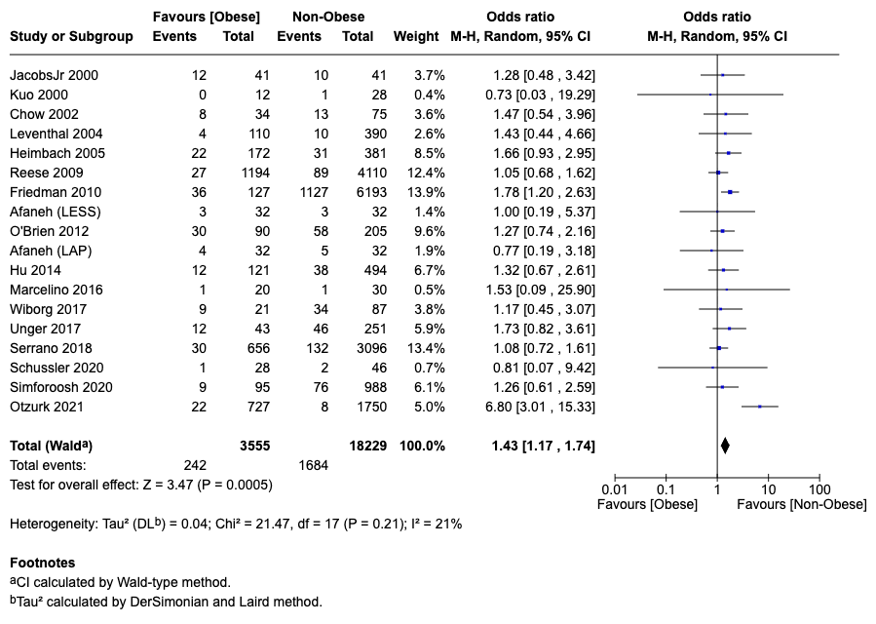
2B. Conversion rate
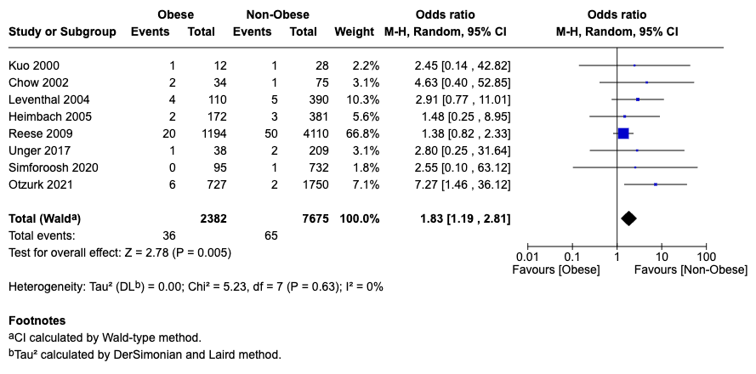

2C. Estimated blood loss
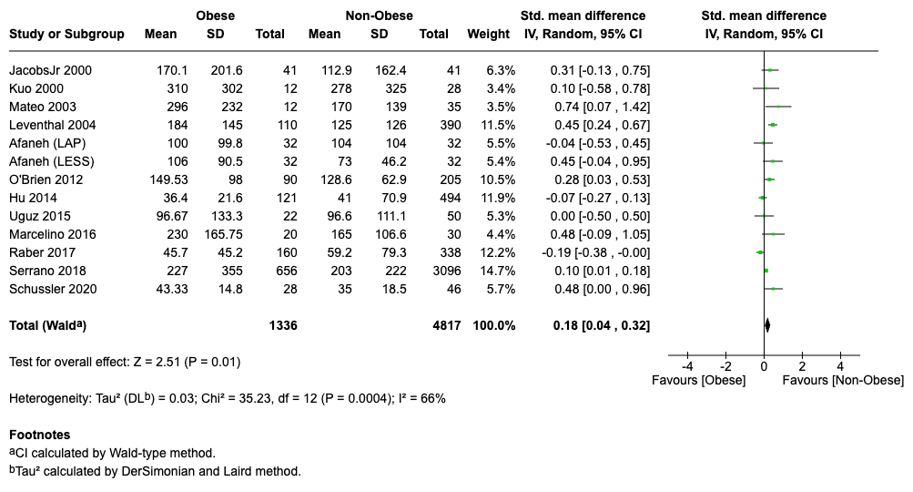

2D. Operative time
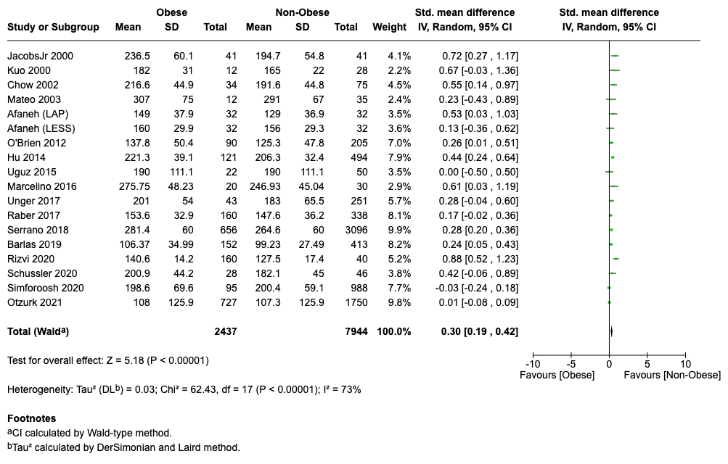

2E. Length of stay
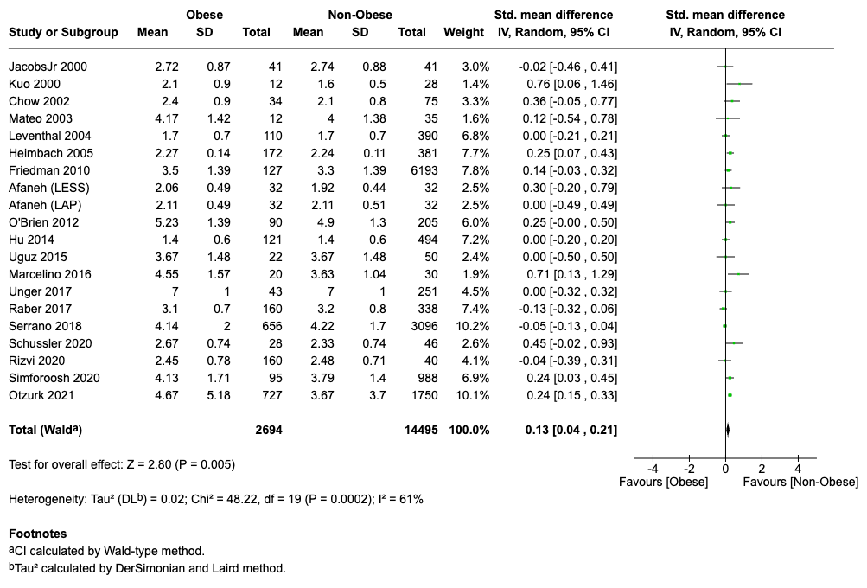
2F. Wound infection rate
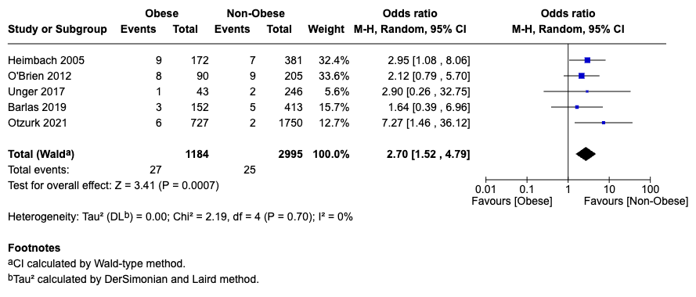

2G. Warm ischemia time
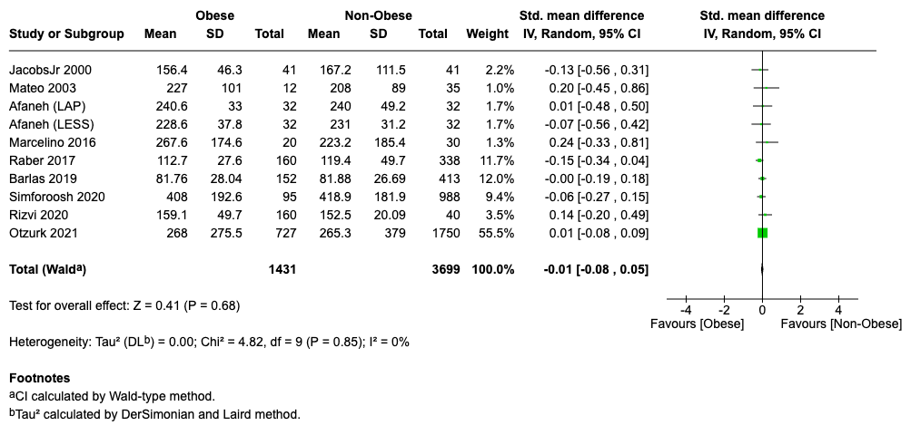

Figure 3: Forest plot comparing Forest plots comparing long-term risks in obese and non-obese donors

3A. Hypertension
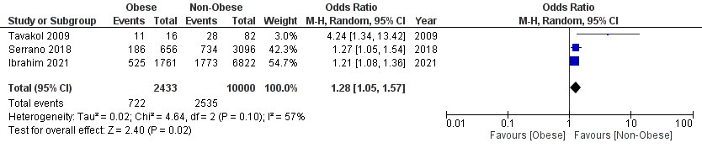
3B. Diabetes Mellitus
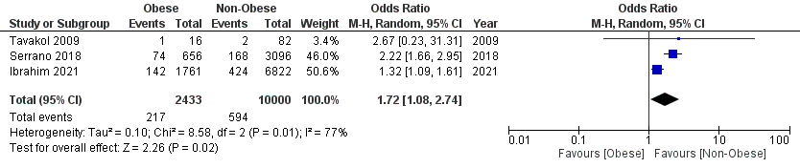
3C. Proteinuria
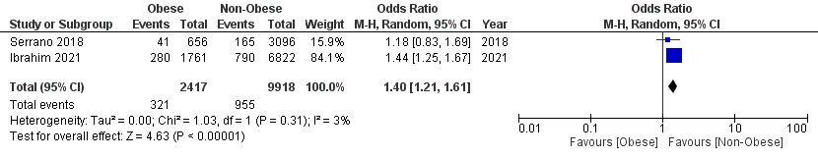
3D. eGFR
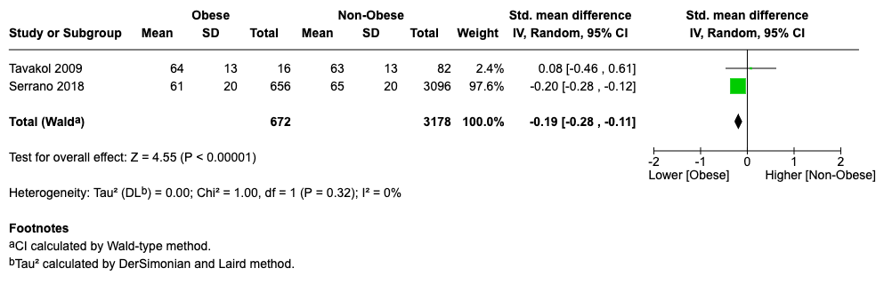
3E. End-stage kidney disease
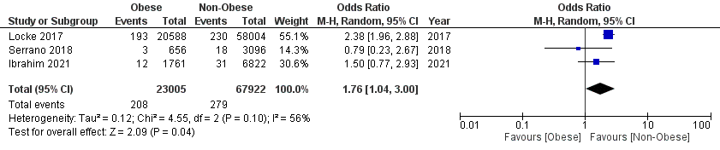
Appendix 1: The search strategy (PubMed)

("Obesity"[MeSH] OR "obesity, morbid"[MeSH] OR "Body Mass Index"[MeSH] OR "Body Weight"[MeSH] OR "Obesity"[Text Word] OR "Overweight"[Text Word] OR "Body Mass Index"[Text Word] OR "Body Weight"[Text Word]) AND ("Living Donors"[MeSH] OR "Living Donor"[Text Word]) AND ("Adult"[MeSH] OR "Male"[MeSH] OR "Female"[MeSH] OR "Adults"[Text Word] OR "Male"[Text Word] OR "Female"[Text Word]) AND ("Kidney"[Text Word] OR "Kidney"[MeSH] OR "Nephrectomy"[Mesh] OR “Nephrectomy”[Text Word])

Appendix 2: The risk of bias assessment of each included study

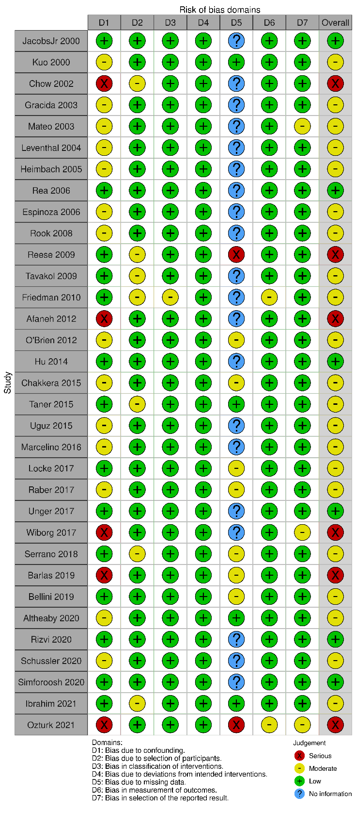

Appendix 3: The risk of bias summary

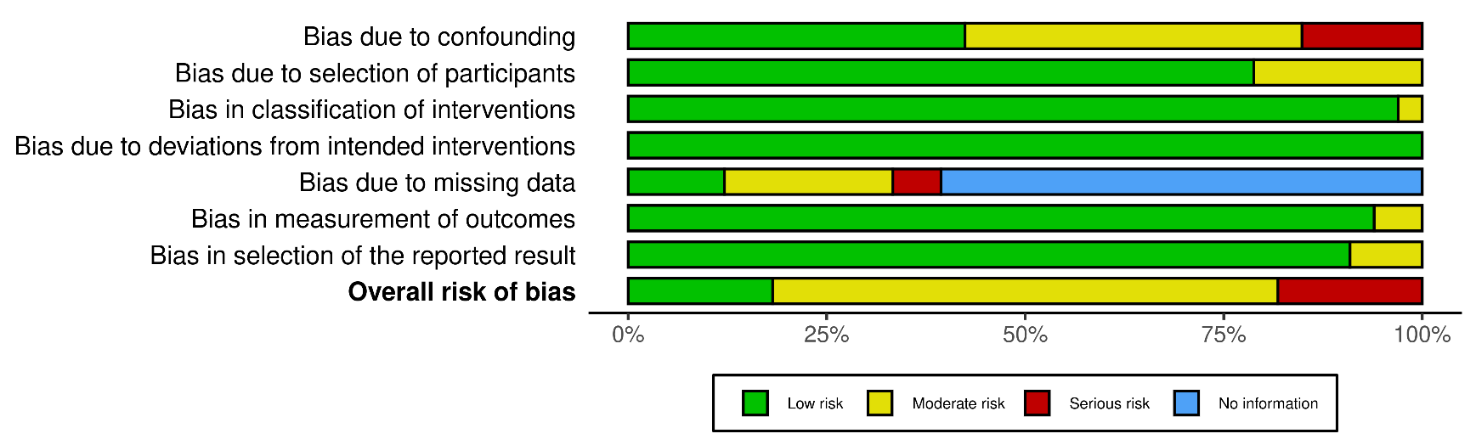

Appendix 4: The GRADE analysis

Certainty assessment |  |  |  |  |  |  | № of patients |  | Effect |  | Certainty | Importance
№ of studies | Study design | Risk of bias | Inconsistency | Indirectness | Imprecision | Other considerations | Obese donors | Non-obese donors | Relative  (95% CI) | Absolute  (95% CI)
Surgical Complications
19 | non-randomised studies | not serious | not serious | not serious | not serious | dose response gradient | 242/3555 (6.8%) | 1684/18229 (9.2%) | OR 1.43  (1.17 to 1.74) | 35 more per 1,000  (from 14 more to 58 more) | ⨁⨁⨁⨁  High | CRITICAL
Conversion rate
8 | non-randomised studies | not serious | not serious | not serious | not serious | strong association | 20/1324 (1.5%) | 32/5256 (0.6%) | OR 3.01  (1.59 to 5.68) | 12 more per 1,000  (from 4 more to 28 more) | ⨁⨁⨁⨁  High | CRITICAL
Estimated Blood loss
13 | non-randomised studies | not serious | serious | not serious | not serious | none | 1336 | 4817 | - | SMD 0.18 SD higher  (0.04 higher to 0.32 higher) | ⨁⨁⨁◯  Moderate | CRITICAL
Operative Time
17 | non-randomised studies | not serious | serious | not serious | not serious | none | 2437 | 7944 | - | SMD 0.3 SD higher  (0.19 higher to 0.42 higher) | ⨁⨁⨁◯  Moderate | IMPORTANT
Length of Stay
21 | non-randomised studies | not serious | serious | not serious | not serious | none | 2694 | 14495 | - | SMD 0.13 SD higher  (0.04 higher to 0.21 higher) | ⨁⨁⨁◯  Moderate | IMPORTANT
Wound infection rate
5 | non-randomised studies | not serious | not serious | not serious | not serious | strong association | 14/978 (1.4%) | 20/2664 (0.8%) | OR 2.96  (1.15 to 7.58) | 14 more per 1,000  (from 1 more to 47 more) | ⨁⨁⨁⨁  High | CRITICAL
Warm ischemia
10 | non-randomised studies | not serious | not serious | not serious | not serious | none | 1431 | 3443 | - | SMD 0.01 lower  (0.08 lower to 0.05 higher) | ⨁⨁⨁⨁  High | IMPORTANT
Hypertension
3 | non-randomised studies | not serious | serious | not serious | not serious | none | 722/2433 (29.7%) | 2535/10000 (25.4%) | OR 1.28  (1.05 to 1.57) | 49 more per 1,000  (from 9 more to 94 more) | ⨁⨁⨁◯  Moderate | CRITICAL
Diabetes Mellitus
3 | non-randomised studies | not serious | very serious | not serious | not serious | none | 217/2433 (8.9%) | 594/10000 (5.9%) | OR 1.72  (1.08 to 2.74) | 39 more per 1,000  (from 4 more to 88 more) | ⨁⨁◯◯  Low | CRITICAL
Proteinuria
2 | non-randomised studies | not serious | not serious | not serious | not serious | none | 321/2417 (13.3%) | 955/9918 (9.6%) | OR 1.40  (1.21 to 1.61) | 34 more per 1,000  (from 18 more to 50 more) | ⨁⨁⨁⨁  High | CRITICAL
eGFR
4 | non-randomised studies | not serious | not serious | not serious | not serious | none | 672 | 3178 | - | SMD 0.19 SD lower  (0.28 lower to 0.11 lower) | ⨁⨁⨁⨁  High | CRITICAL
End-stage Kidney Disease
3 | non-randomised studies | not serious | serious | not serious | not serious | none | 208/23005 (0.9%) | 279/67922 (0.4%) | OR 1.76  (1.04 to 3.00) | 3 more per 1,000  (from1 more to 8 more) | ⨁⨁⨁◯  Moderate | CRITICAL
CI: confidence interval; OR: odds ratio; SMD: standardised mean difference

Appendix 5: The PRIMSA checklist

Section and Topic | Item # | Checklist item | Page #
TITLE
Title | 1 | Identify the report as a systematic review. | 1
ABSTRACT
Abstract | 2 | See the PRISMA 2020 for Abstracts checklist. | 4
INTRODUCTION
Rationale | 3 | Describe the rationale for the review in the context of existing knowledge. | 6
Objectives | 4 | Provide an explicit statement of the objective(s) or question(s) the review addresses. | 7
METHODS
Eligibility criteria | 5 | Specify the inclusion and exclusion criteria for the review and how studies were grouped for the syntheses. | 8
Information sources | 6 | Specify all databases, registers, websites, organisations, reference lists and other sources searched or consulted to identify studies. Specify the date when each source was last searched or consulted. | 8
Search strategy | 7 | Present the full search strategies for all databases, registers and websites, including any filters and limits used. | 7, 8
Selection process | 8 | Specify the methods used to decide whether a study met the inclusion criteria of the review, including how many reviewers screened each record and each report retrieved, whether they worked independently, and if applicable, details of automation tools used in the process. | 8
Data collection process | 9 | Specify the methods used to collect data from reports, including how many reviewers collected data from each report, whether they worked independently, any processes for obtaining or confirming data from study investigators, and if applicable, details of automation tools used in the process. | 8, 9
Data items | 10a | List and define all outcomes for which data were sought. Specify whether all results that were compatible with each outcome domain in each study were sought (e.g. for all measures, time points, analyses), and if not, the methods used to decide which results to collect. | 9
 | 10b | List and define all other variables for which data were sought (e.g. participant and intervention characteristics, funding sources). Describe any assumptions made about any missing or unclear information. | 8, 9
Study risk of bias assessment | 11 | Specify the methods used to assess risk of bias in the included studies, including details of the tool(s) used, how many reviewers assessed each study and whether they worked independently, and if applicable, details of automation tools used in the process. | 9
Effect measures | 12 | Specify for each outcome the effect measure(s) (e.g. risk ratio, mean difference) used in the synthesis or presentation of results. | 9
Synthesis methods | 13a | Describe the processes used to decide which studies were eligible for each synthesis (e.g. tabulating the study intervention characteristics and comparing against the planned groups for each synthesis (item #5)). | 9
 | 13b | Describe any methods required to prepare the data for presentation or synthesis, such as handling of missing summary statistics, or data conversions. | 9
 | 13c | Describe any methods used to tabulate or visually display results of individual studies and syntheses. | 8, 9
 | 13d | Describe any methods used to synthesize results and provide a rationale for the choice(s). If meta-analysis was performed, describe the model(s), method(s) to identify the presence and extent of statistical heterogeneity, and software package(s) used. | 8, 9
 | 13e | Describe any methods used to explore possible causes of heterogeneity among study results (e.g. subgroup analysis, meta-regression). | 9
 | 13f | Describe any sensitivity analyses conducted to assess robustness of the synthesized results. | 9
Reporting bias assessment | 14 | Describe any methods used to assess risk of bias due to missing results in a synthesis (arising from reporting biases). | 9
Certainty assessment | 15 | Describe any methods used to assess certainty (or confidence) in the body of evidence for an outcome. | 9
RESULTS
Study selection | 16a | Describe the results of the search and selection process, from the number of records identified in the search to the number of studies included in the review, ideally using a flow diagram. | 10
 | 16b | Cite studies that might appear to meet the inclusion criteria, but which were excluded, and explain why they were excluded. | 10
Study characteristics | 17 | Cite each included study and present its characteristics. | 10
Risk of bias in studies | 18 | Present assessments of risk of bias for each included study. | 14
Results of individual studies | 19 | For all outcomes, present, for each study: (a) summary statistics for each group (where appropriate) and (b) an effect estimate and its precision (e.g. confidence/credible interval), ideally using structured tables or plots. | 11-14
Results of syntheses | 20a | For each synthesis, briefly summarise the characteristics and risk of bias among contributing studies. | 14
 | 20b | Present results of all statistical syntheses conducted. If meta-analysis was done, present for each the summary estimate and its precision (e.g. confidence/credible interval) and measures of statistical heterogeneity. If comparing groups, describe the direction of the effect. | 11-14
 | 20c | Present results of all investigations of possible causes of heterogeneity among study results. | 11-14
 | 20d | Present results of all sensitivity analyses conducted to assess the robustness of the synthesized results. | 14
Reporting biases | 21 | Present assessments of risk of bias due to missing results (arising from reporting biases) for each synthesis assessed. | 14
Certainty of evidence | 22 | Present assessments of certainty (or confidence) in the body of evidence for each outcome assessed. | 14
DISCUSSION
Discussion | 23a | Provide a general interpretation of the results in the context of other evidence. | 15
 | 23b | Discuss any limitations of the evidence included in the review. | 18
 | 23c | Discuss any limitations of the review processes used. | 18
 | 23d | Discuss implications of the results for practice, policy, and future research. | 15-18
OTHER INFORMATION
Registration and protocol | 24a | Provide registration information for the review, including register name and registration number, or state that the review was not registered. | 7
 | 24b | Indicate where the review protocol can be accessed, or state that a protocol was not prepared. | 7
 | 24c | Describe and explain any amendments to information provided at registration or in the protocol.
Support | 25 | Describe sources of financial or non-financial support for the review, and the role of the funders or sponsors in the review. | 1
Competing interests | 26 | Declare any competing interests of review authors. | 1
Availability of data, code and other materials | 27 | Report which of the following are publicly available and where they can be found: template data collection forms; data extracted from included studies; data used for all analyses; analytic code; any other materials used in the review. | 1

From: Page MJ, McKenzie JE, Bossuyt PM, Boutron I, Hoffmann TC, Mulrow CD, et al. The PRISMA 2020 statement: an updated guideline for reporting systematic reviews. BMJ 2021;372:n71. doi: 10.1136/bmj.n71. This work is licensed under CC BY 4.0. To view a copy of this license, visit https://creativecommons.org/licenses/by/4.0/

Supplementary Table S1: Sub -group analyses of short-term outcomes Comparing Obese vs Non-Obese Living Kidney Donors

Outcome | Weighted average effect  (Primary Analysis) | Extreme BMI categories effect  (Sub-group analysis 1) | Laparoscopic-only pooled effect  (Sub-group analysis 2)
Surgical complications | OR 1.43 (1.17, 1.74) | OR 1.54 (1.21, 1.96) | OR 1.69 (1.12, 2.55)
Conversion rate | OR 1.83 (1.19, 2.81) | OR 3.01 (1.59, 5.68) | OR 4.20 (1.86, 9.47)
Estimated blood loss | SMD 0.18 (0.04, 0.32) | SMD 0.20 (0.05, 0.36) | SMD 0.23 (0.01, 0.45)
Operative time | SMD 0.30 (0.19, 0.42) | SMD 0.34 (0.22, 0.47) | SMD 0.39 (0.22, 0.56)
Length of stay | SMD 0.13 (0.04, 0.21) | SMD 0.17 (0.06, 0.29) | SMD 0.22 (0.08, 0.37)
Infection rate | OR 2.70 (1.52, 4.79) | OR 2.96 (1.15, 7.58) | OR 4.49 (1.44, 13.93)
Warm ischemia time | SMD −0.01 (−0.08, 0.05) | SMD −0.01 (−0.08, 0.05) | SMD −0.01 (−0.08, 0.05)

Supplementary Table S2: Comparison of perioperative outcomes
Outcome | Lafranca et al Meta-analysis (2013) | This Meta-analysis | Novel Contributions
Surgical complications | No significant difference | Significantly increased | Previously non-significant; now significant due to increased power
Conversion to Open Surgery | OR = 1.69 (significantly increased) | significantly increased | Higher magnitude of risk; updated estimate from more recent studies
Estimated Blood Loss | No significant difference | Significantly increased | New significant finding with more studies included
Operative Time | Significantly increased in obese donors | Significantly increased in obese donors | Confirmed and updated with larger sample
Length of Stay | No significant difference | Significantly increased | New significant finding; not observed previously
Wound Infection rate | Not reported | Significantly increased | New outcome analyzed; not previously reported
Warm Ischemia Time | No significant difference | No significant difference | Confirmed no difference

Appendix 6: The Data Extraction Sheet (Excel)

Appendix 7: Sub-group Analysis 1 - Extremes of BMI (when reported)
A. Surgical complications
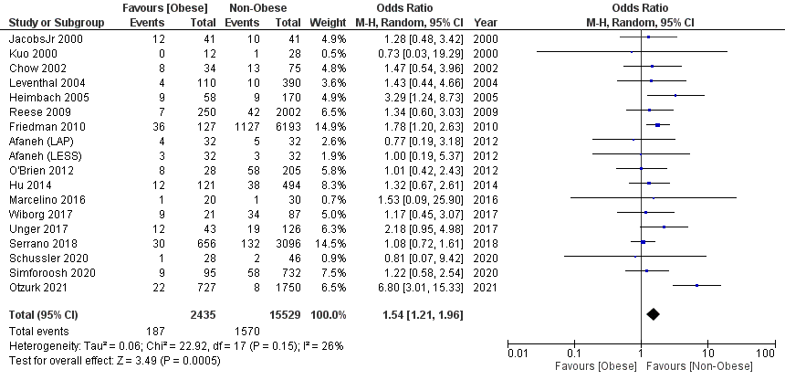
B. Conversion rate
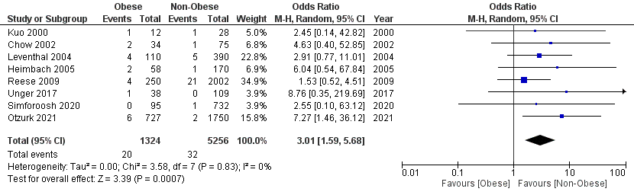
C. Estimated blood loss
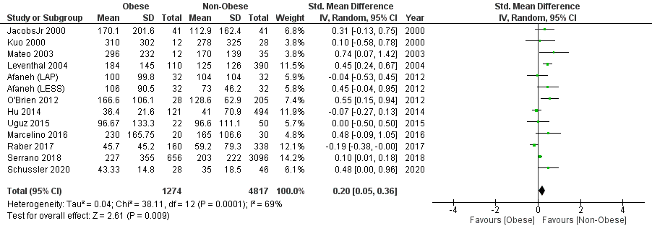

D. Operative time
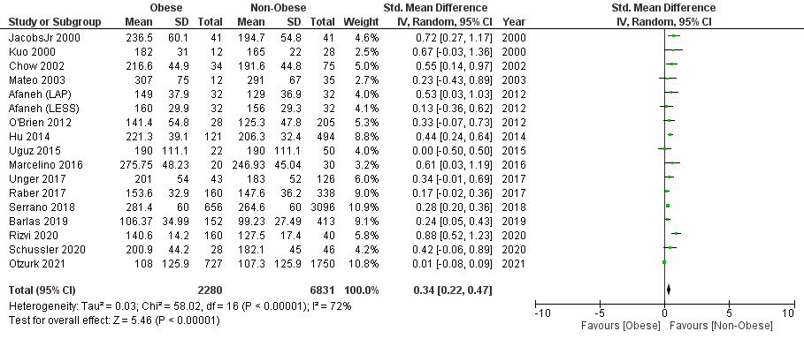
E. Length of stay
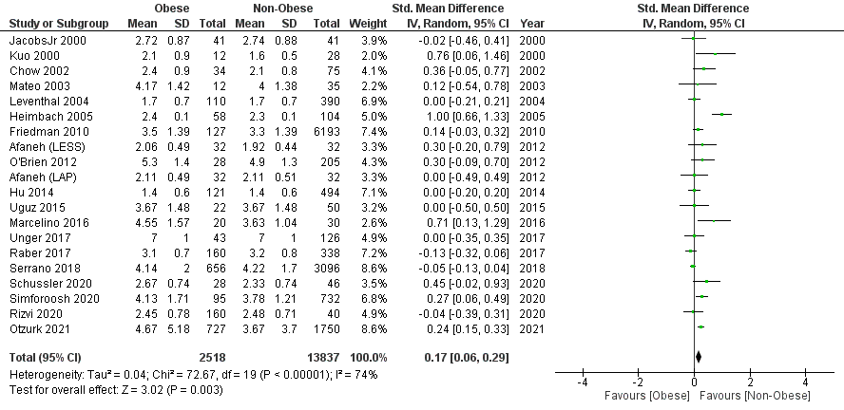
F. Infection rate
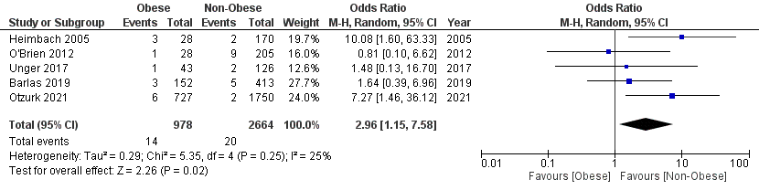

G. Warm Ischemia Time
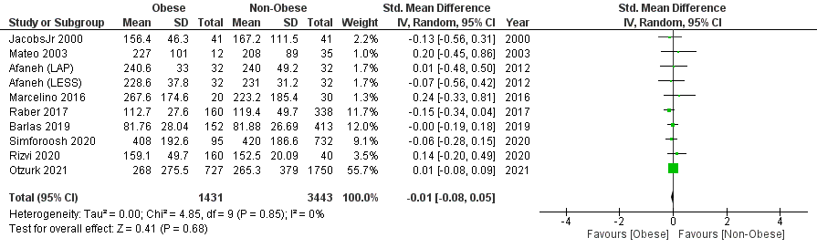

Appendix 8: Sub-group Analysis 2 - Laparoscopic surgery only
A. Surgical complications
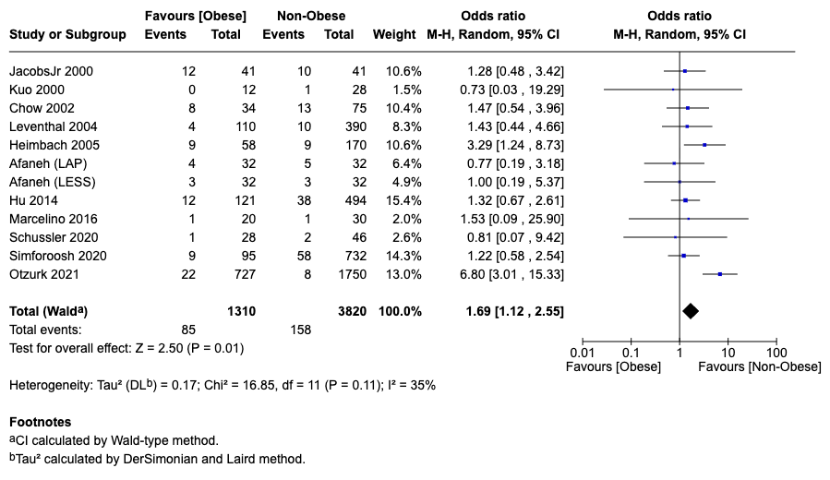
B. Conversion rate
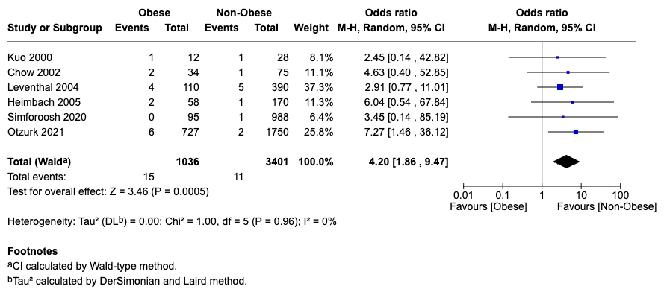

C. Estimated blood loss
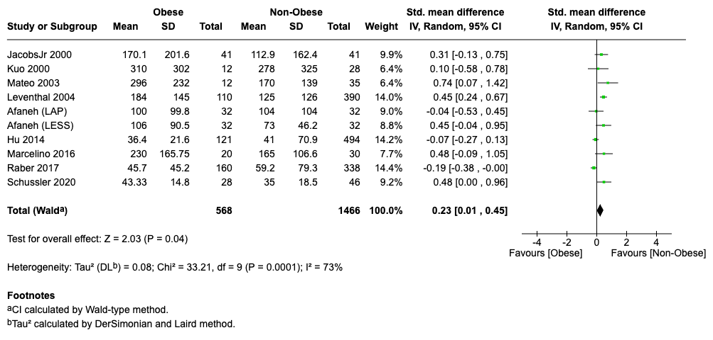
D. Operative time
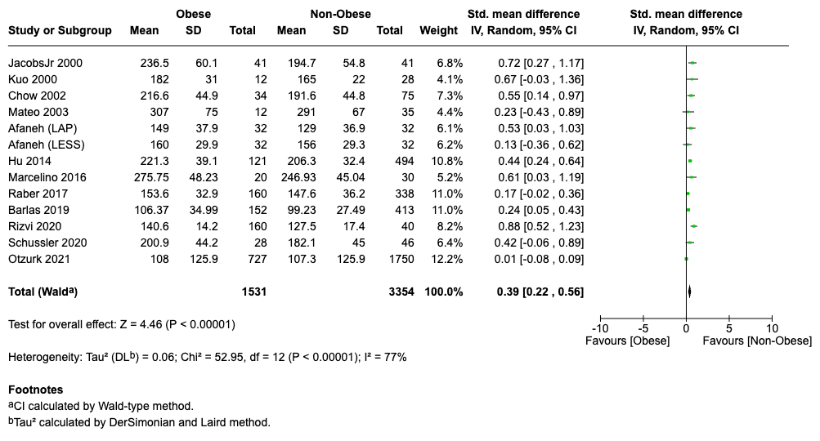

E. Length of stay
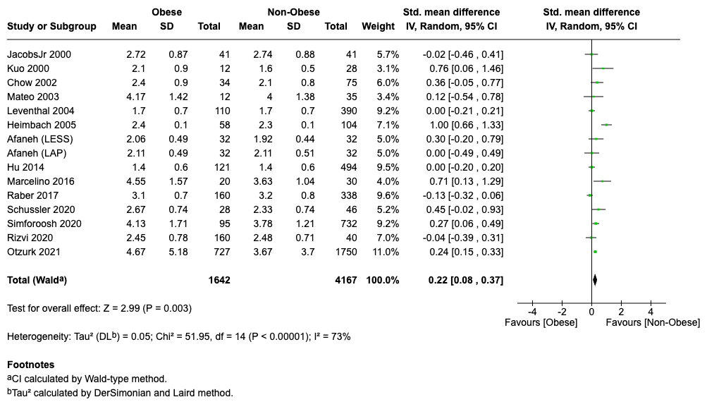
F. Infection rate
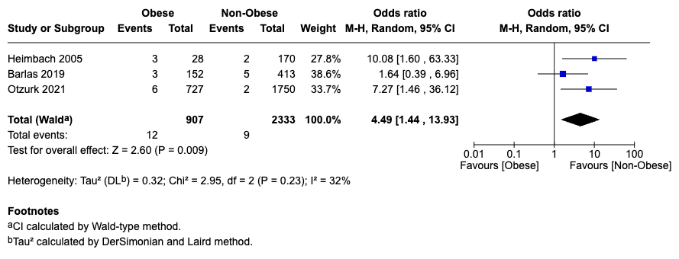

G. Warm Ischemia Time
